# Gallery

## Description

## This element comprises a Title, a Body, and an Image Display. You have the flexibility to include the Title and Body or opt for either. You can also customize the gallery's appearance and select the number of images through the grid styling dropdown menu.

## Grid Styling

* 2 Image-Type 1

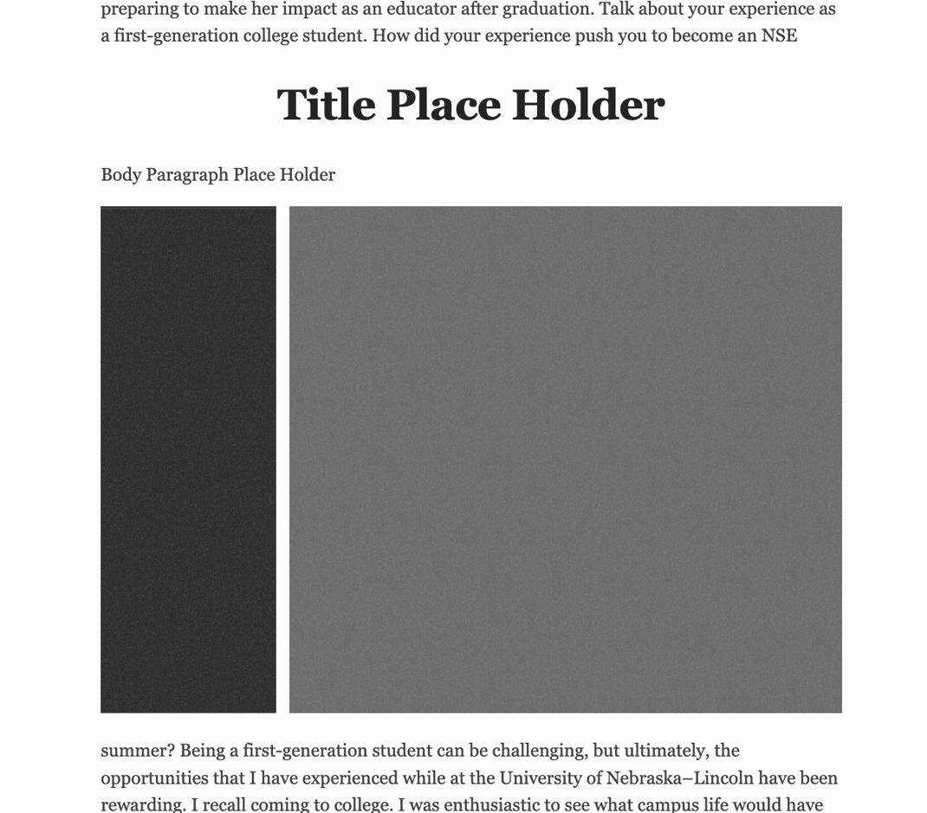

2

1

* 2 Images-Type 2

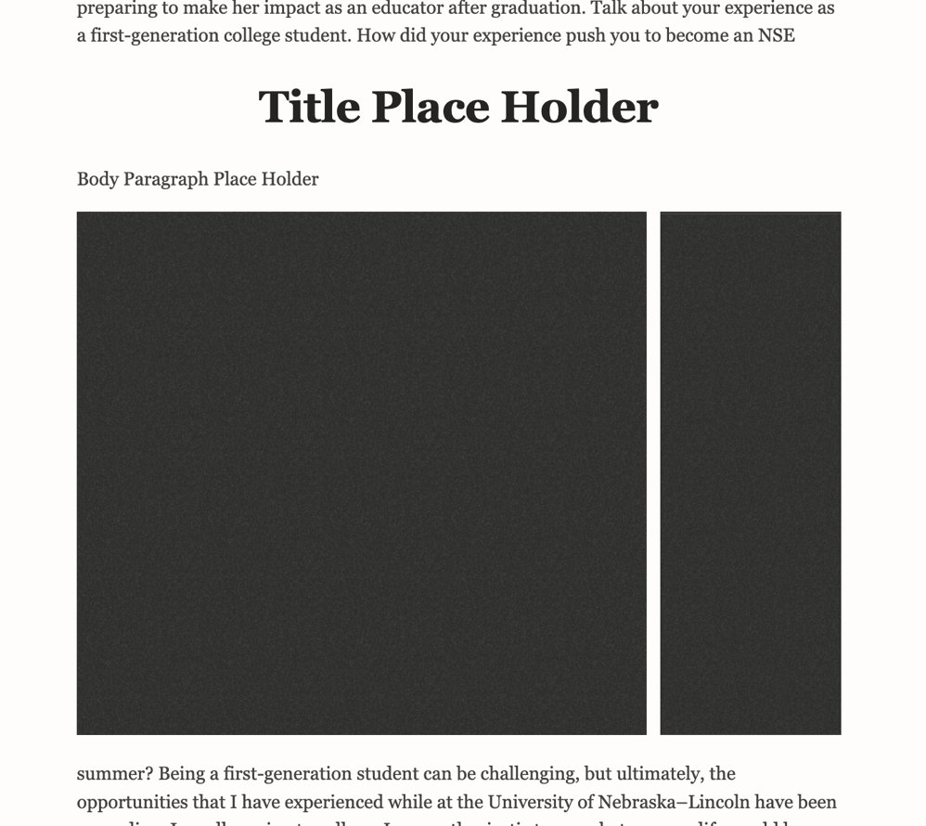

2

1

* 2 Wide-Images-Type 1

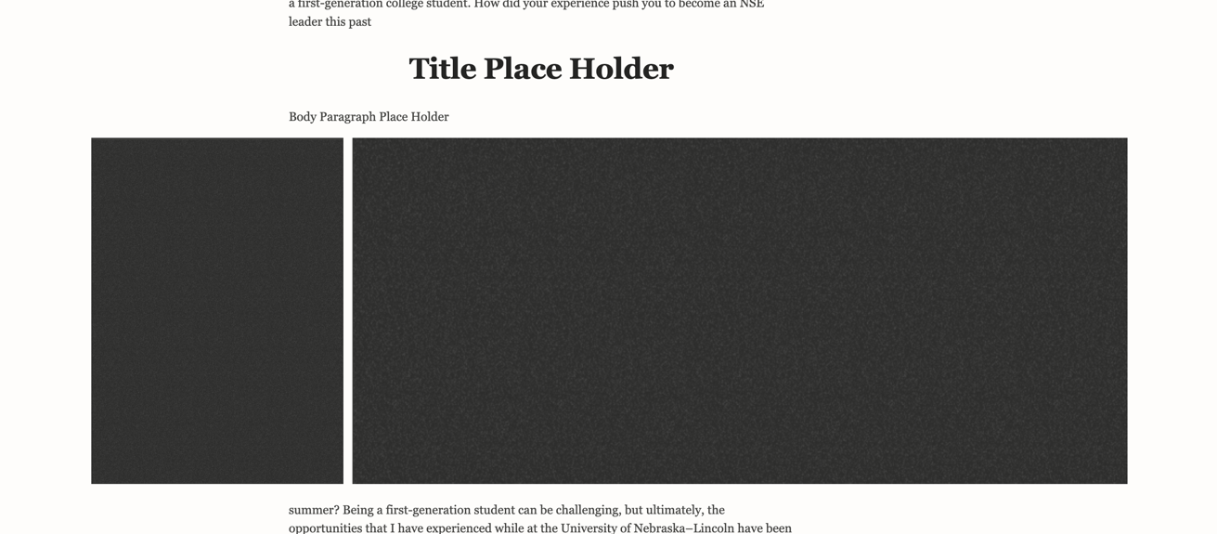

2

1

* 2 Wide-Images-Type 2

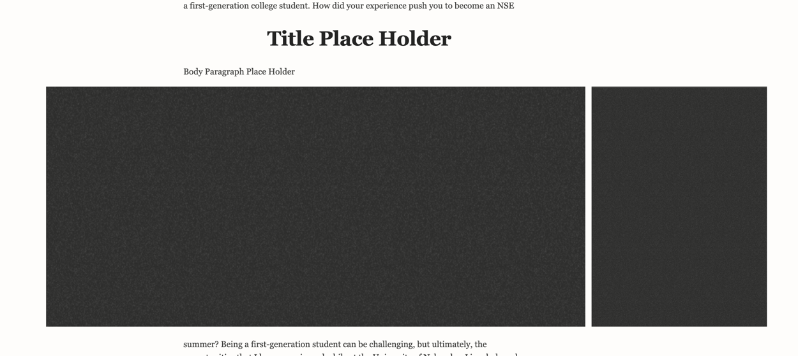

2

1

* 3 Images-Type 1

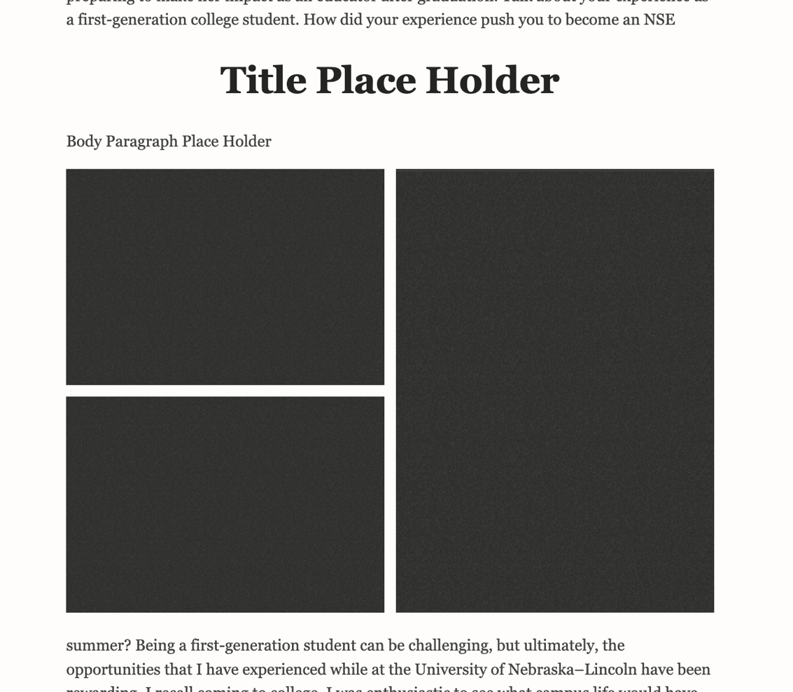

3

2

1

* 3 Images-Type 2

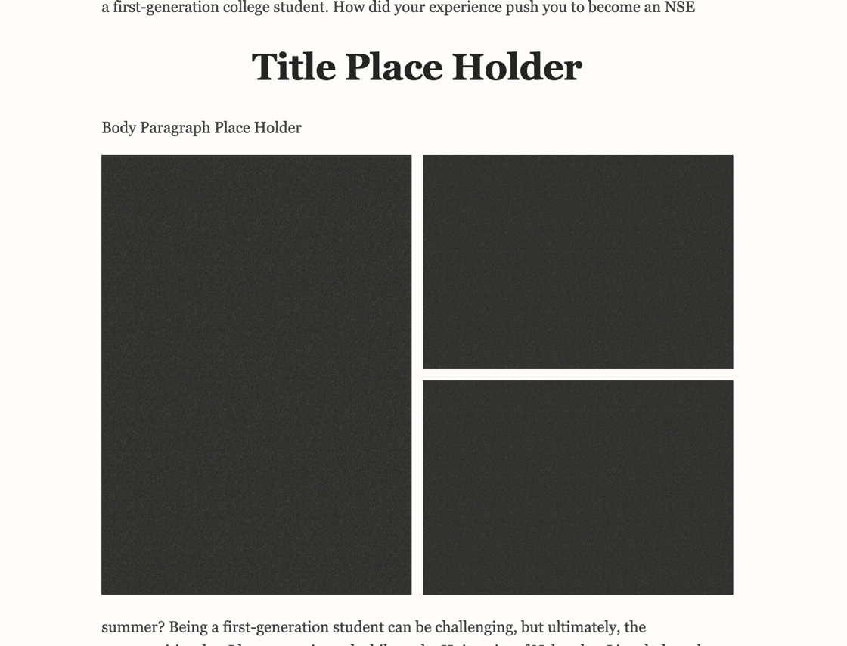

3

2

1

* 3 Images-Type 3

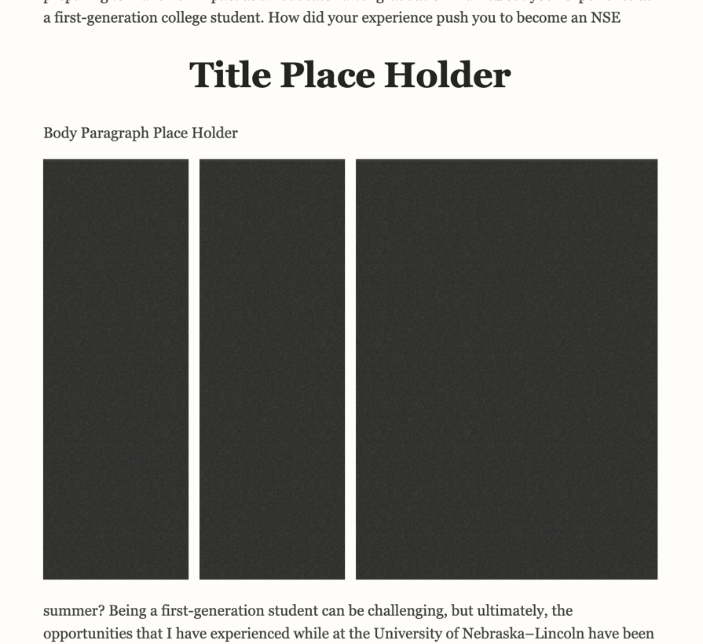

3

2

1

* 3 Images-Type 4

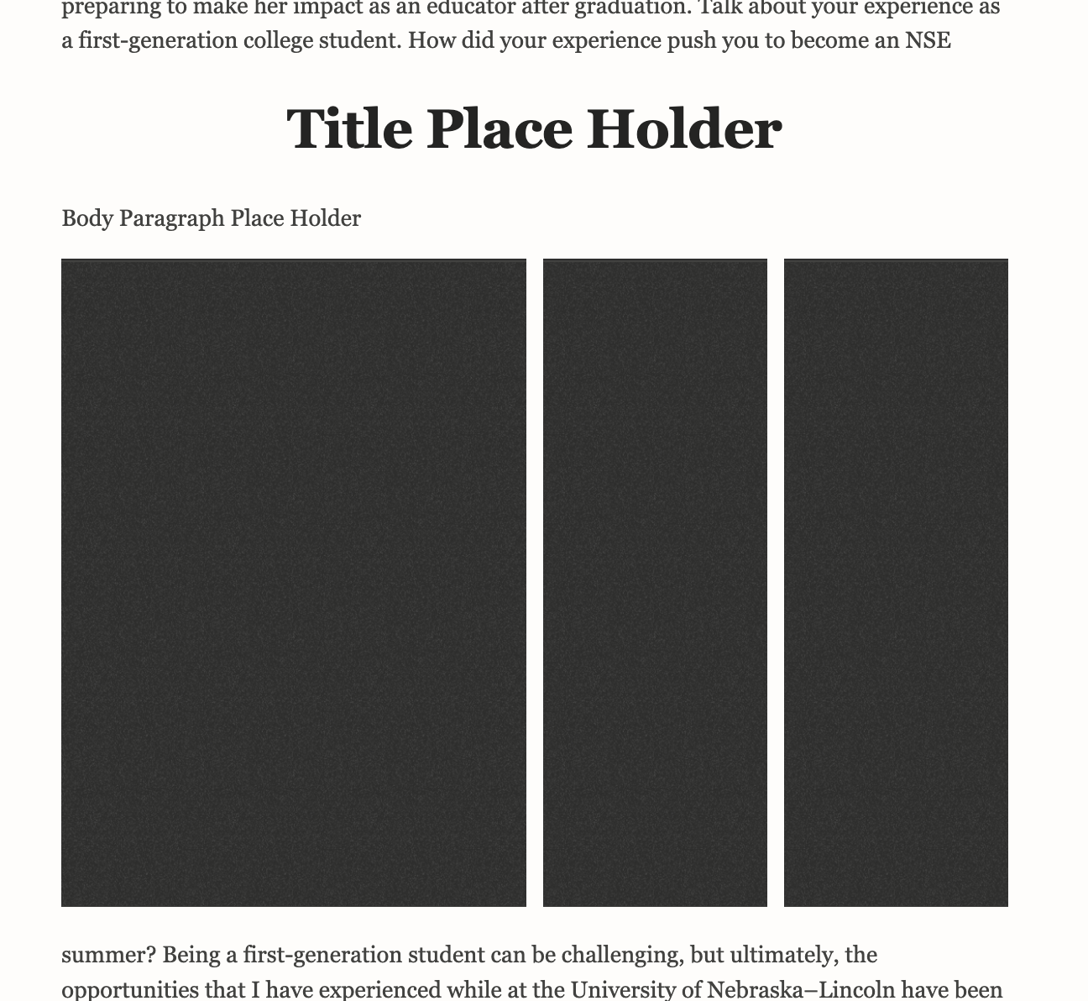

2

3

1

* 3 Wide-Images-Type 1

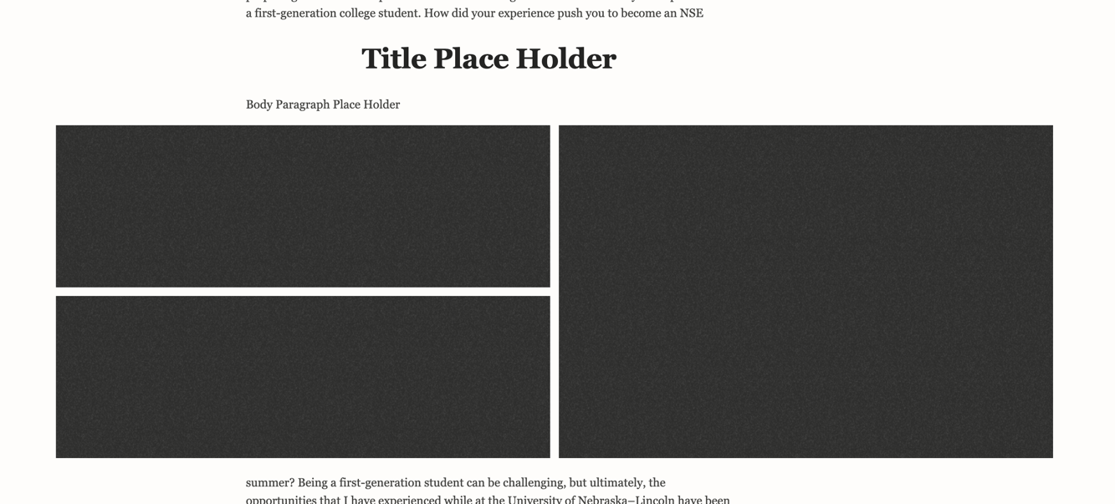

3

2

1

* 3 Wide-Images-Type 2

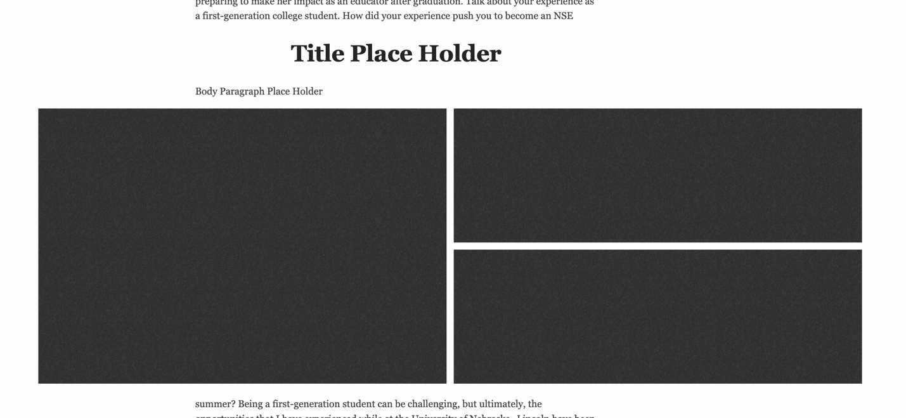

3

2

1

* 3 Wide-Images-Type 3

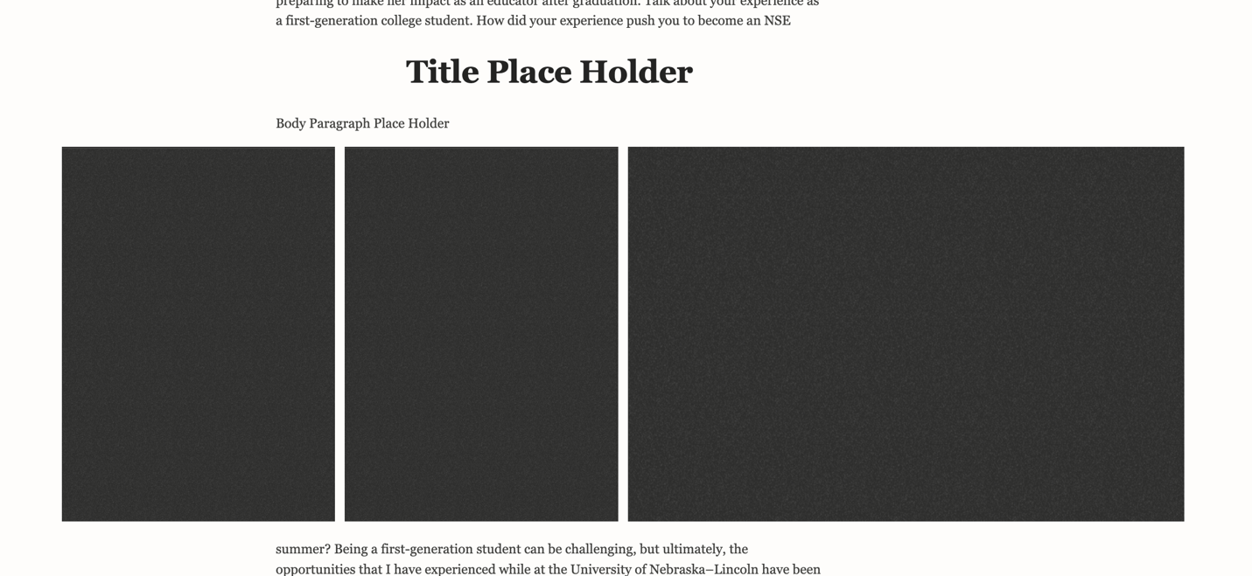

2

3

1

* 3 Wide-Images-Type 4

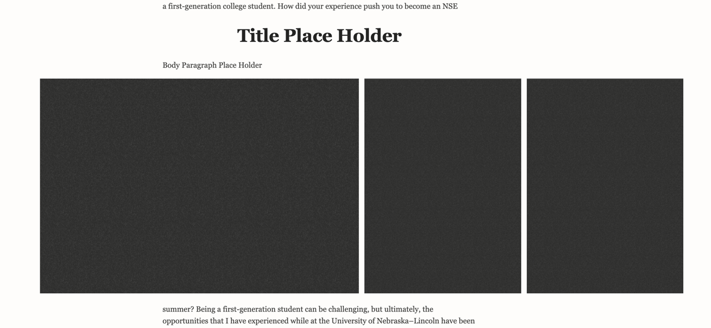

3

2

1

* 4 Images-Type 1

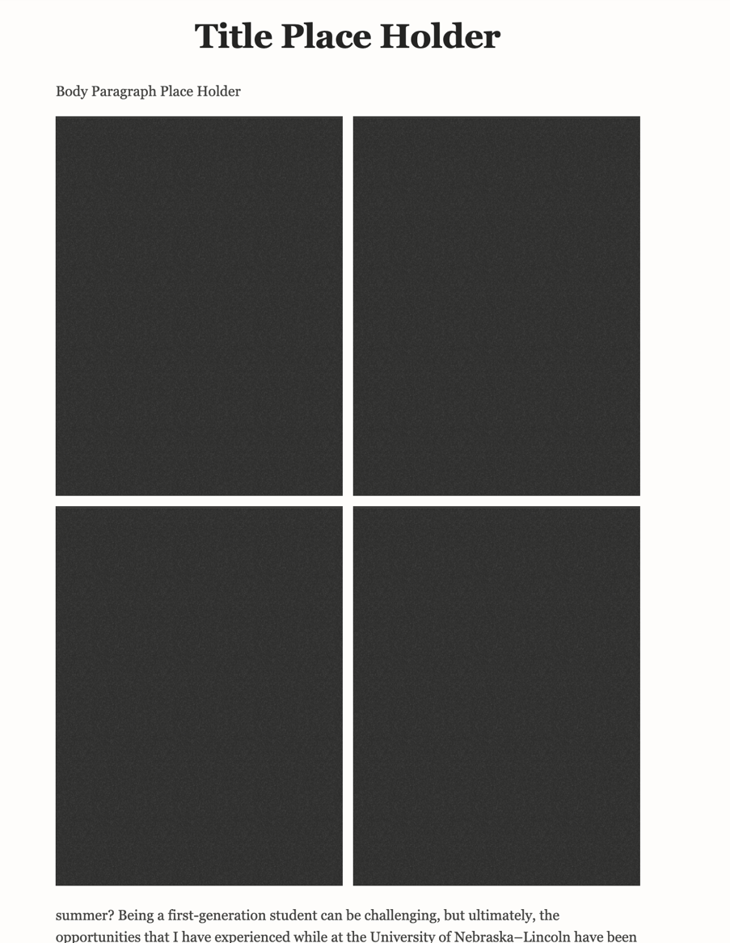

2

4

3

1

* 4 Wide-Images-Type 1

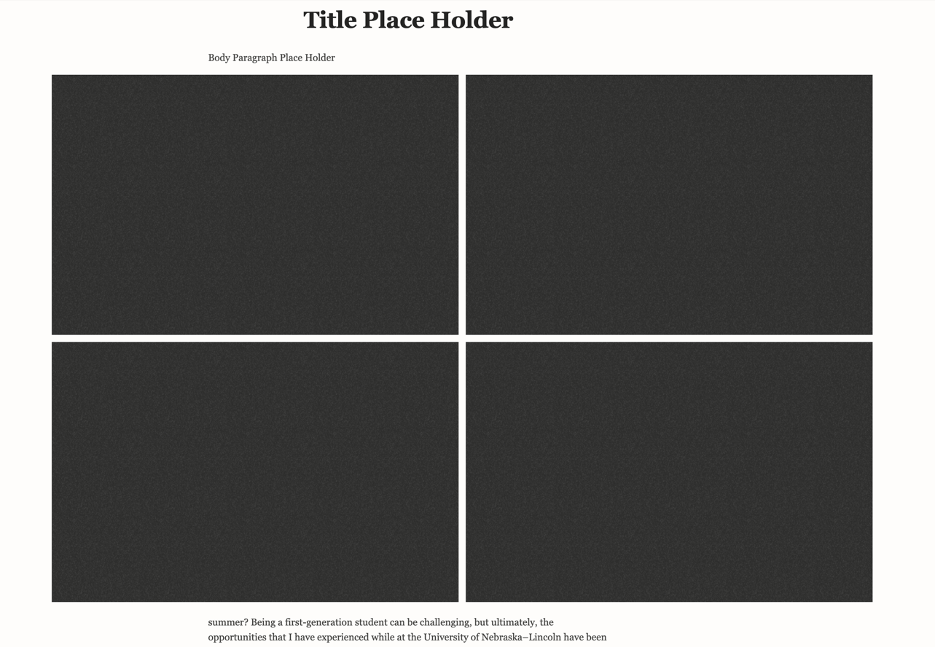

4

2

1

3

* 5 Images-Type 1

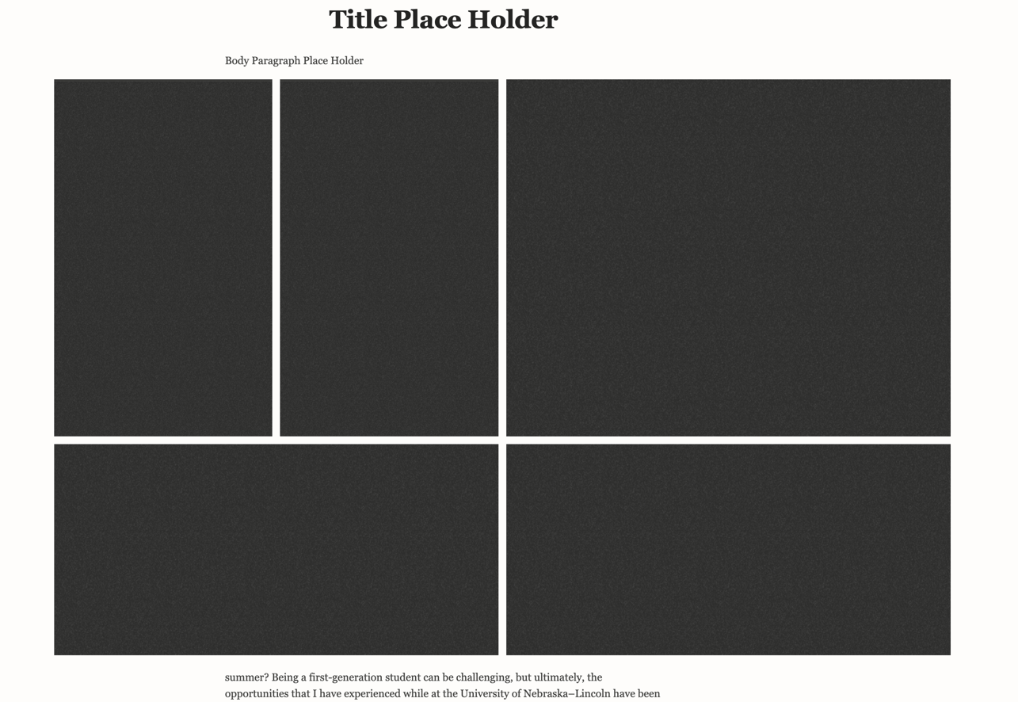

5

1

2

3

4

* 5 Images-Type 2

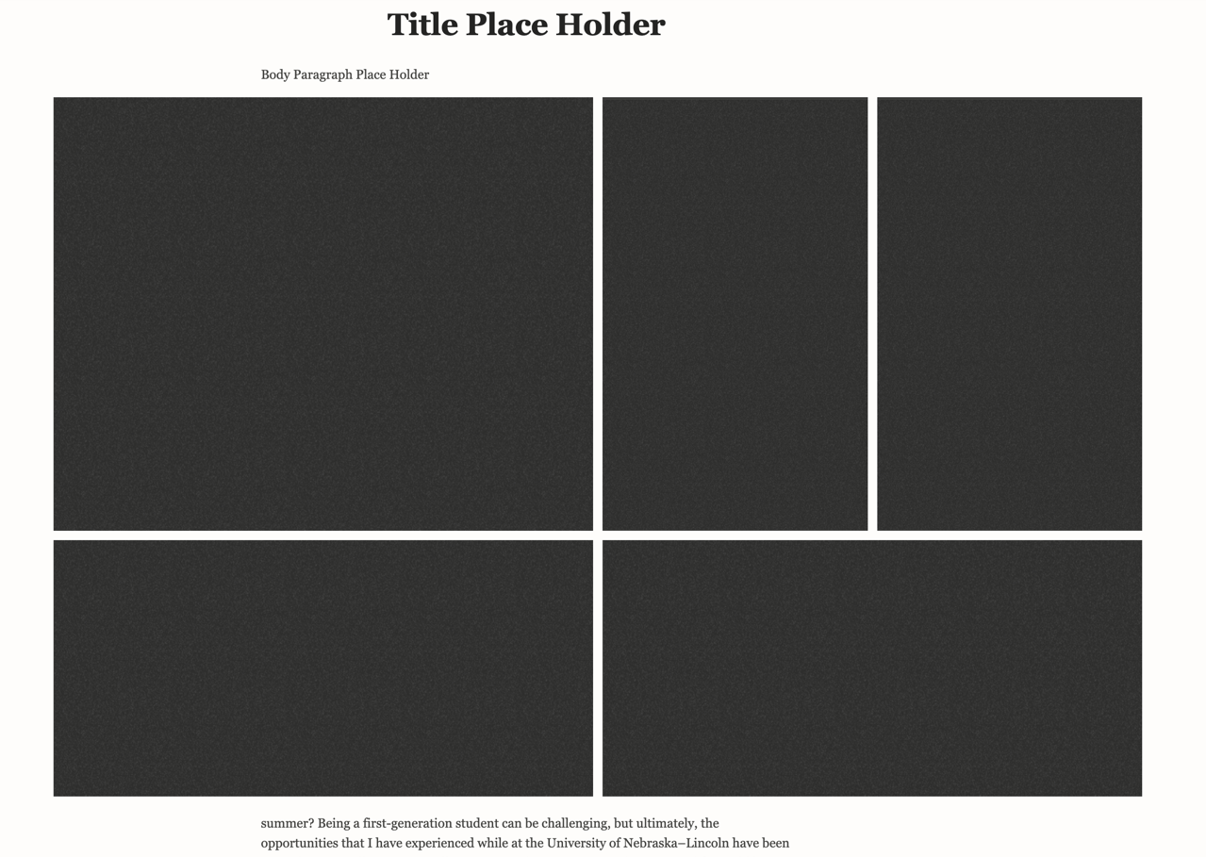

5

4

3

2

1

* 6 Images-Type 1

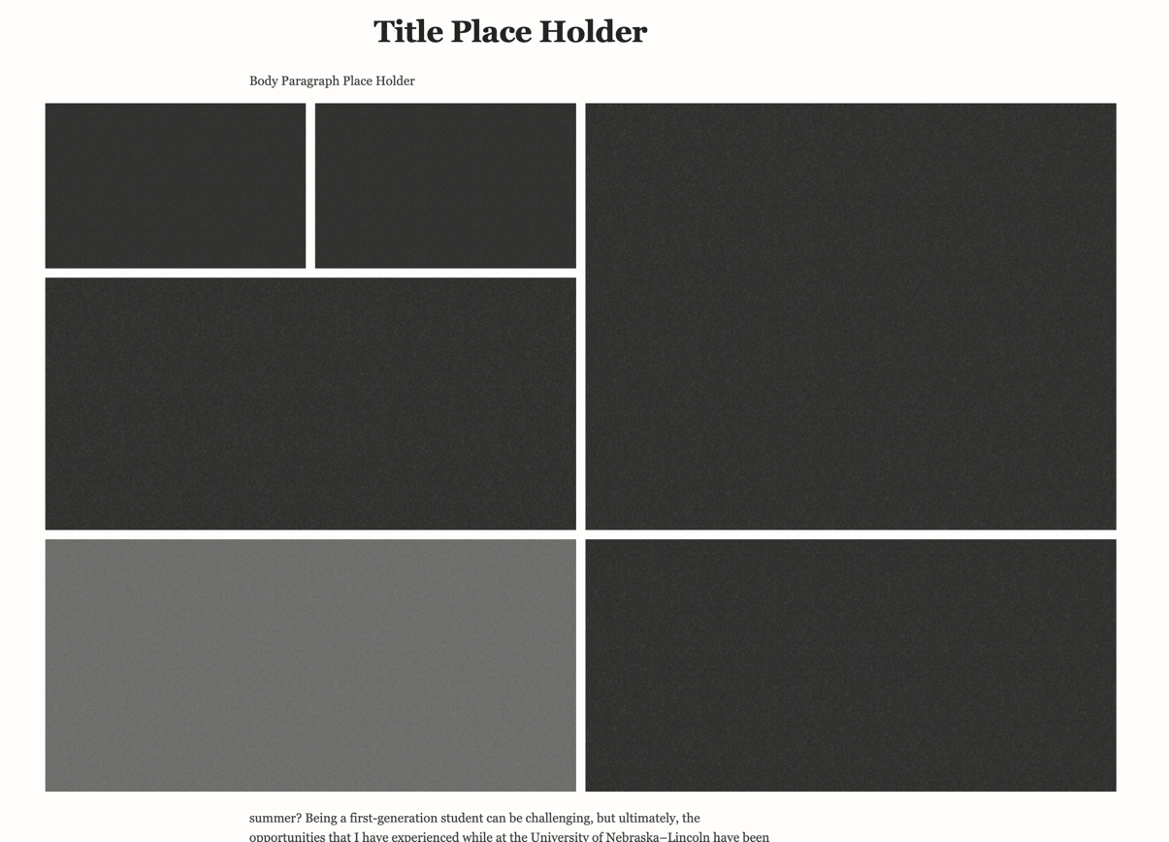

6

5

4

3

2

1

* 6 Images-Type 2

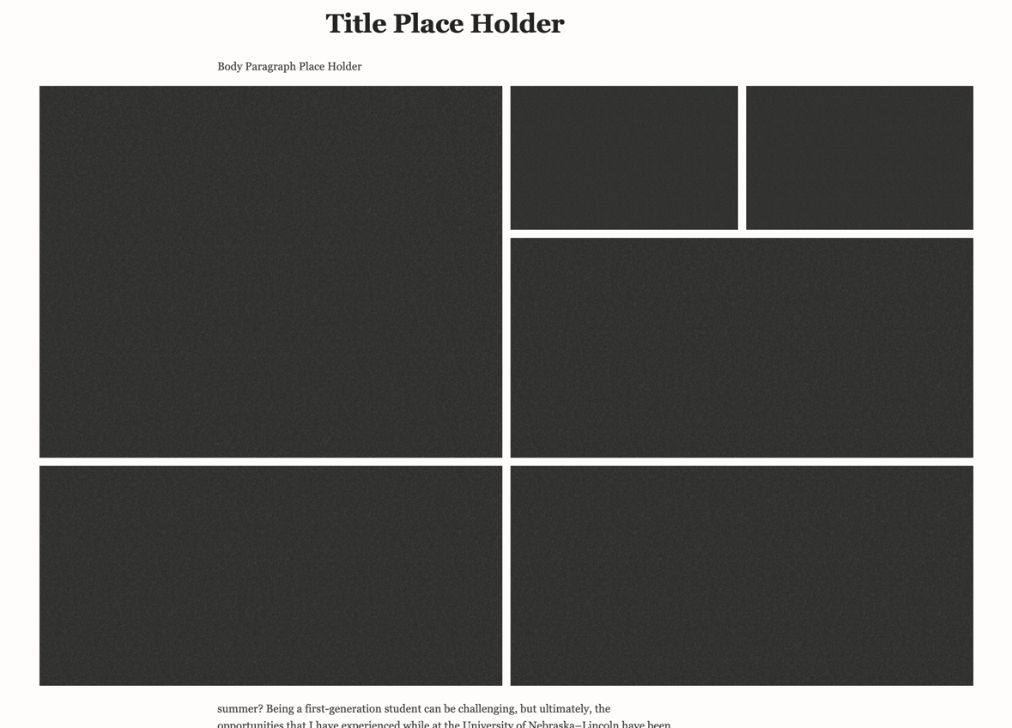

6

5

4

3

2

1

* 7 Images-Type 1

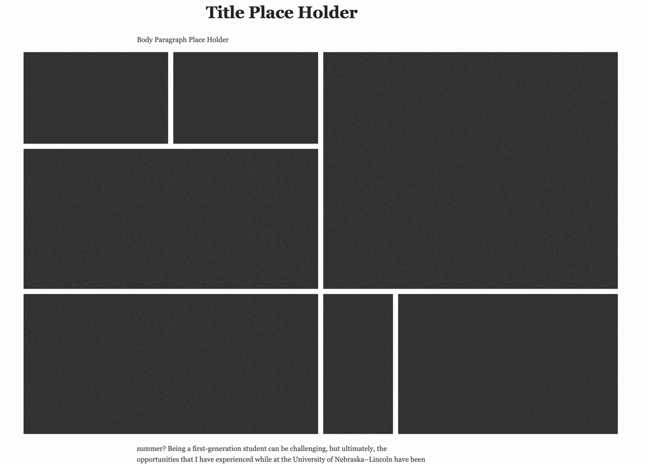

7

6

5

4

3

2

1

* 7 Images-Type 2

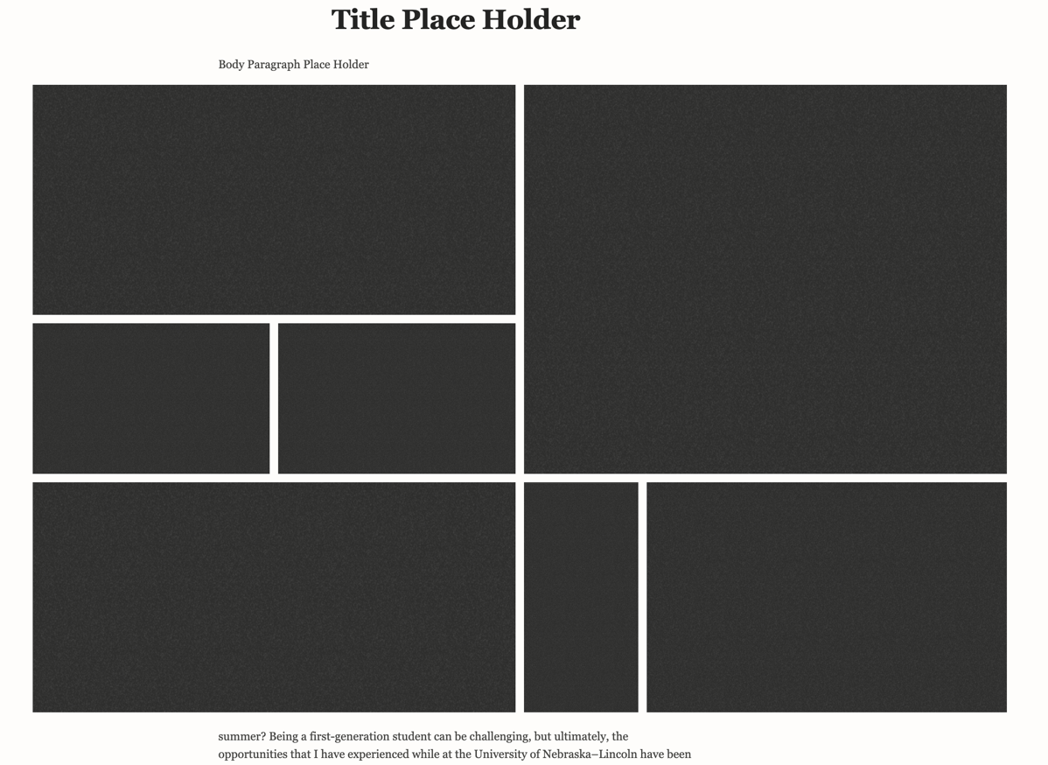

7

6

5

4

3

2

1